5.12 How to enable ContainerLogV2

Currently our original schema is ContainerLog, ContainerLogV2 will be the default schema if we create a new cluster and ContainerLog table will be retired on 30th September 2026. This documentation is aimed to enable ContainerLogV2.

For more information, see the following article:

[Configure the ContainerLogV2 schema for Container Insights - Azure Monitor | Microsoft Learn](https://learn.microsoft.com/en-us/azure/azure-monitor/containers/container-insights-logs-schema)

Steps:

1. Run the below pipeline to enable the “ContainerLogV2”.

[Pipelines - Runs for APM0004459-Aks Cluster Management Update ContianerLogV2 in Azure insight](https://dev.azure.com/dow-vsts/DevSecOps/_build?definitionId=8225)

1. Choose the “main” branch
2. Select the name of the cluster

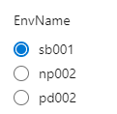

1. Choose the type of MonitorSettings (Choose “Cost-optimized” by default):

1. (Optional) Enter the proper “ChangeNumber” if you run it for Production:

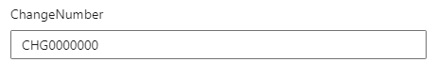

1. Go to the Portal to Check the configuration of the insight if it has been configured as “ContainerLogV2”

[AKS-NP-002 - Microsoft Azure](https://portal.azure.com/?feature.msaljs=true#@bsnconnect.onmicrosoft.com/resource/subscriptions/6060ea50-d00d-4c40-8219-546ed259f9e5/resourceGroups/RG-NP-0001581/providers/Microsoft.ContainerService/managedClusters/AKS-NP-002/infrainsights)

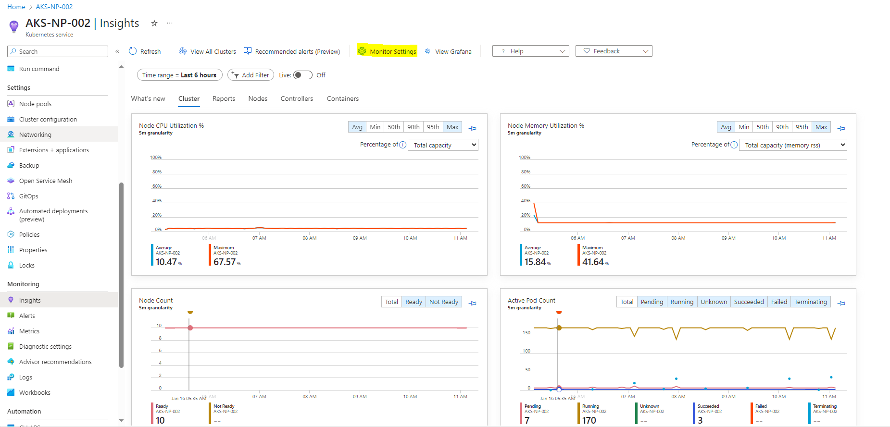

1. Modify the ConfigMaps of the pods which are used as agents for Azure Monitoring.

[Pipelines - Runs for APM0004459-AksBasic (azure.com)](https://dev.azure.com/dow-vsts/DevSecOps/_build?definitionId=3896)

1. Choose the “main” branch
2. Select the name of the cluster



1. Choose the deployment:

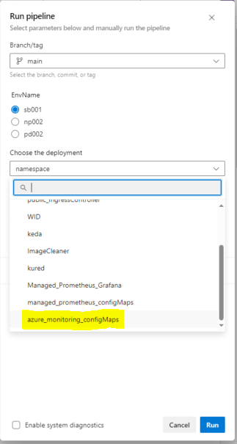

1. (Optional) Enter the proper “ChangeNumber” if you run it for Production:

1. Go to the Portal to Check the configuration and use the below query in the insight if it has been configured as “ContainerLogV2”.
2. Click the “Configuration”:

[AKS-SB-001 - Microsoft Azure](https://portal.azure.com/?feature.msaljs=true#@bsnconnect.onmicrosoft.com/resource/subscriptions/6060ea50-d00d-4c40-8219-546ed259f9e5/resourceGroups/RG-T-0003321/providers/Microsoft.ContainerService/managedClusters/AKS-SB-001/overview)

[AKS-NP-002 - Microsoft Azure](https://portal.azure.com/?feature.msaljs=true#@bsnconnect.onmicrosoft.com/resource/subscriptions/6060ea50-d00d-4c40-8219-546ed259f9e5/resourceGroups/RG-NP-0001581/providers/Microsoft.ContainerService/managedClusters/AKS-NP-002/configuration)

[AKS-PD-002 - Microsoft Azure](https://portal.azure.com/?feature.msaljs=true#@bsnconnect.onmicrosoft.com/resource/subscriptions/6060ea50-d00d-4c40-8219-546ed259f9e5/resourceGroups/RG-PD-0001547/providers/Microsoft.ContainerService/managedClusters/AKS-PD-002/overview)

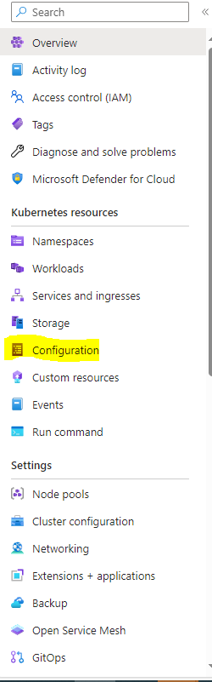

1. Filter the ConfigMap:

ConfigMap: container-azm-ms-agentconfig

Namespace: kube-system

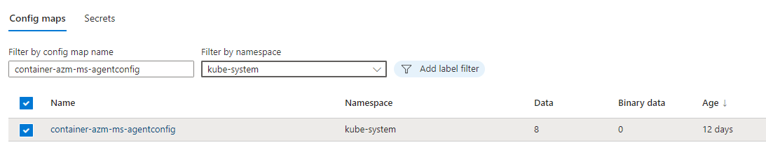

1. Click this ConfigMap:

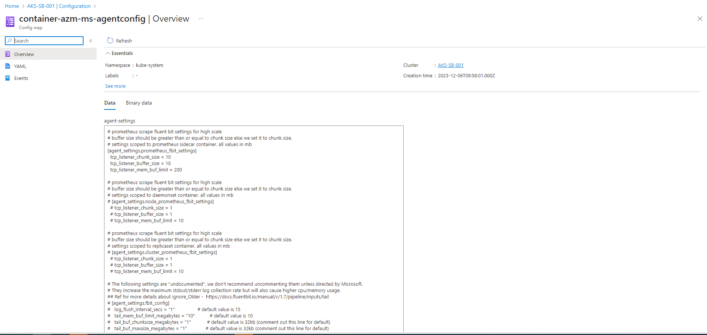

1. Check the Configuration and use the tool “Find” of your browser.

Make sure these two Parameters have been configured as the below pictures.

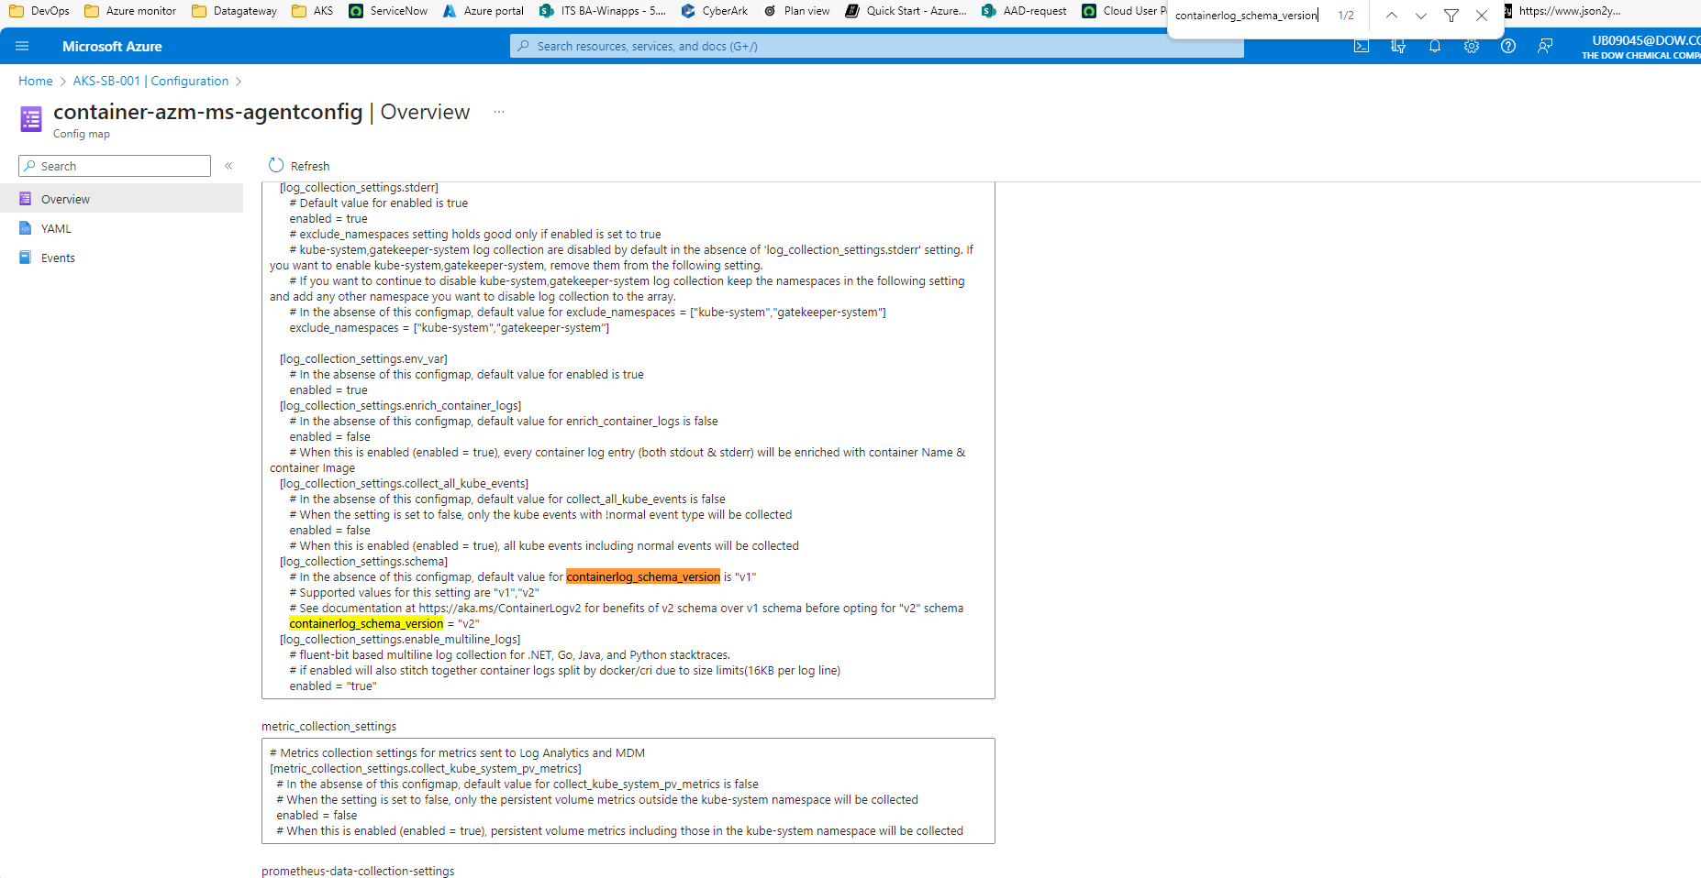

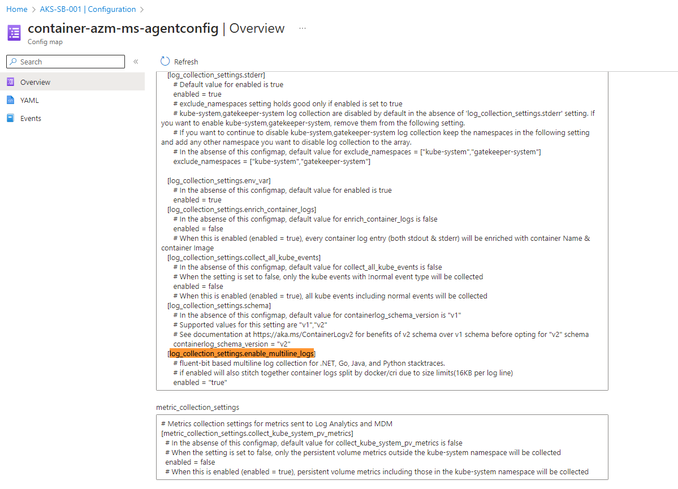

1. Go to the “logs” to check the table called ContainerLogV2 if it has the data, and the logs if they are already multiline.

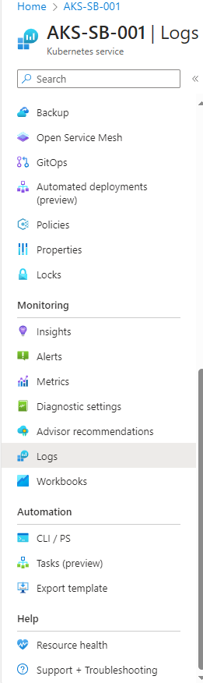

Run the following scripts to make sure the table has the new data and the logs are multiline.

ContainerLogV2

| project TimeGenerated, LogMessage, PodName, PodNamespace

| where PodNamespace contains "apm0005739"

| where LogMessage contains "System"

